Two accounts of Fixed Deposit with maturity date and Expired status at OLP:

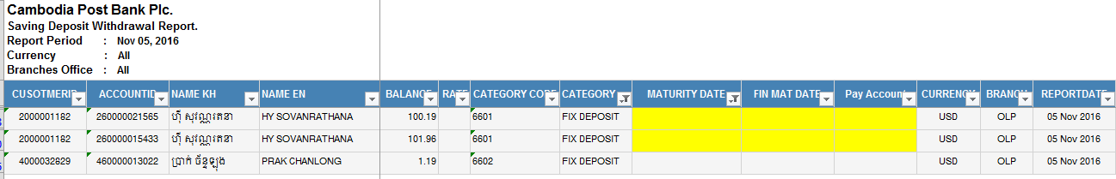

1. Customer Name: HY SOVANRATHANA

Customer ID: 2000001182

Account Number: 260000015433

Maturity Date: 04 Oct 2016

Account Status: EXPIRED

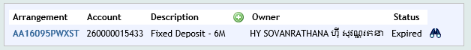

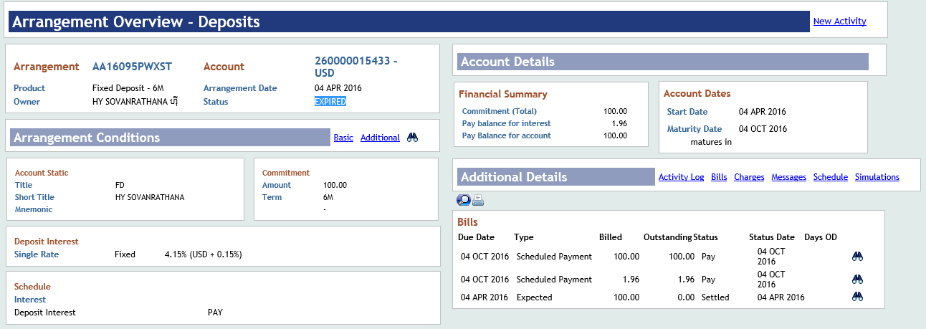

Account Statement:

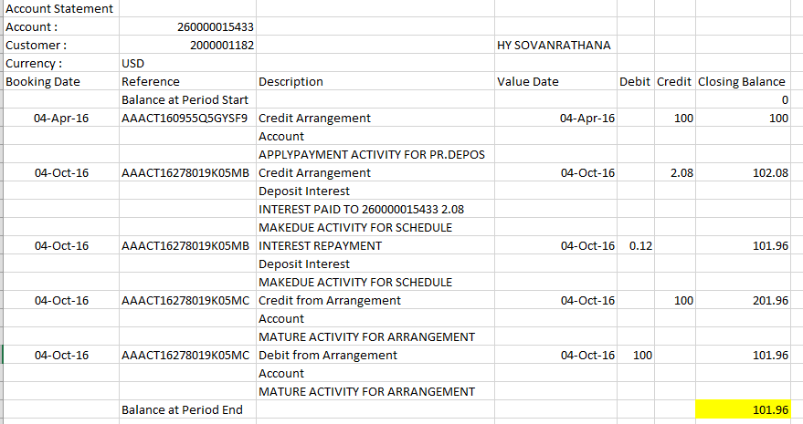

1. Customer Name: HY SOVANRATHANA

Customer ID: 2000001182

Account Number: 260000021565

Maturity Date: 04 Oct 2016

Account Status: EXPIRED

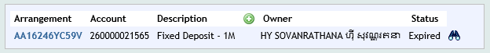

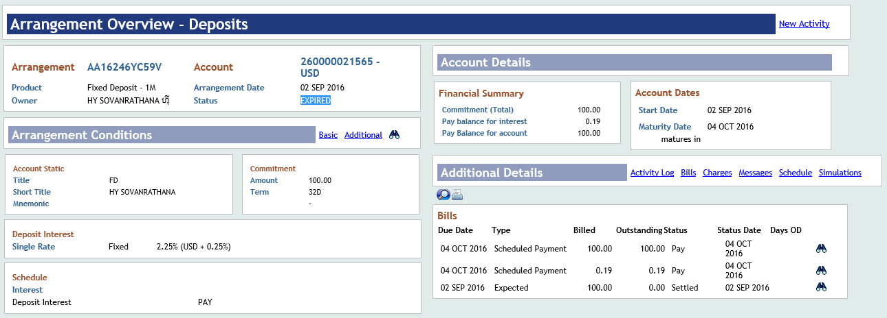

Account Statement:

